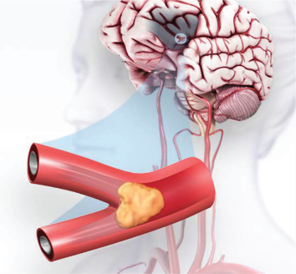
WEAG 50+ Community Group: Medical Educational Lecture

"BE FAST! Time is brain:
Basic training in stroke recognition skills”
WIth interactive Q&A session
"

Learning Objectives:
1. Define the main types of stroke, common causes, and risk factors
2. Understand how a stroke occurs and the urgency of the crisis,
i.e. the importance of seeking immediate medical care to achieve the best possible outcome
3. Learn to rapidly recognize the warning signs of possible stroke using the mnemonic “BE FAST!”
4. Become empowered to help yourself and others in the case of acute stroke

Serendipity Zapanta Rinonos, M.D., Ph.D., is completing her Neurology Residency at the Medical College of Virginia/VCUHS, after which she will be a Clinical Instructor at UCLA Medical Center during her Clinical and Research Fellowship in Neuro-Oncology. She was selected by the American Academy of Neurology as a recipient of the “Futures in Neurological Research” Scholarship. Originally from Manhattan, New York, Dr. Rinonos is an alumna of The Governor’s School (Neurochemistry Senior Thesis) in Richmond, VA, and graduated with honors in Neurobiology as an accelerated graduate from Cornell University as a Howard Hughes Research Scholar. Subsequently, she completed a Clinical and Research Mentorship in Neurosurgery under the training of William Broaddus, M.D, Ph.D., at MCV. Dr. Rinonos completed her M.D. and Ph.D. in Cell Biology with a Neuroscience emphasis at the Medical Scientist Training Program of Case Western Reserve University, School of Medicine, where she was a recipient of a pre-doctoral Neuroscience T32 NIH training grant. Successfully matching into Neurosurgery Residency at MCV, after two years, she decided to transfer to Neurology Residency with the intent of ultimately pursuing an academic translational career as physician-scientist, focusing on mitochondrial molecular biology to develop novel treatments and paradigms of neurologic disease. During residency, she has received multiple awards, including “Most Likely to Win a Nobel Prize,” an oral presentation award from the Dept. of Neurosurgery for research on the natural progression of meningiomas, and the Neuroscience ICU patient-nominated “Acorn Award” for patient care excellence.
Growing up in a family of educators, Dr. Rinonos inherited a passion for empowering her patients, family and friends through teaching medical concepts, especially pertaining to brain health. Connected with West End Assembly of God since middle school and high school days in the Handbell Choir and Youth Choir, upon moving back to Richmond for residency training, she joined the WEAG Orchestra as a violinist, during her weekends off from work. On occasion, she has joined the WEAG Ladies’ Tuesday Bible Study worship team as a guest violinist. She has given lectures to the elementary school-aged girls at WEAG and is also eager to share her enthusiasm for brain health with the 50+ Community Group.
MONDAY, June 11, 2020 ■ 11 AM via ZOOM
INERACTIVE Q&A SESSION TO FOLLOW LECTURE

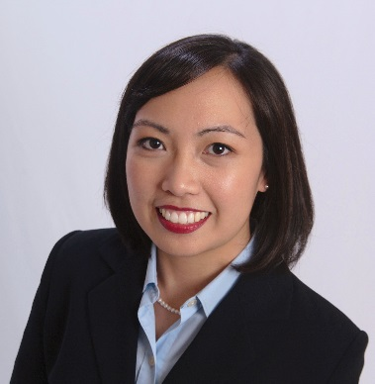

https://neurology.vcu.edu/

