Ancient sacred texts

For The world’s oldest & most influential religions

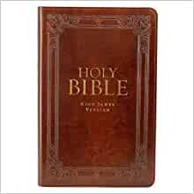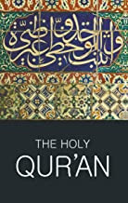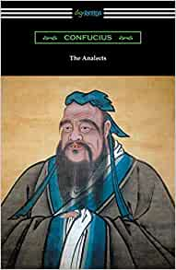

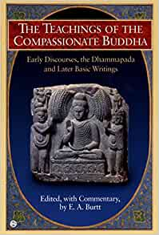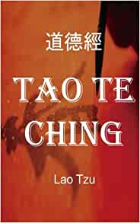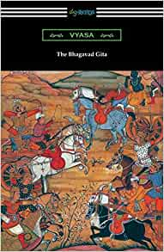

West End Assembly of God
Sue Schlesman
2020

SYLLABUS & ASSIGNMENTS

West End Assembly of God, 2020
ZOOM format, Tuesday, 7-8:30 pm

Date | Guest speaker | Sacred text assignment DUE TODAY | Discussion/class material  IN CLASS TODAY
7/14/20 | Dr. Dave DeMasters—  co-host & moderator |  | Christianity/background
7/21/20 | Praveen & Veena Bunyan | Read from The Bhagavad Gita, The Compassionate Buddha | Hinduism, Buddhism
7/28/20 | Jayson Casper | Read from The Qu’ran | Islam
8/4/20 | NO CLASS
8/11/20 | TBA | Read from the Holy Bible | Christianity
8/18/20 | Chris Geartner | Read from the Tao Te Ching,  The Analects of Confucius | Taoism, Confucianism
8/25/20 | Dave DeMasters—  co-host | Read from the Holy Bible | Christianity

Introduction to sacred texts

“Religion comes naturally, even instinctively, to human beings.”—CNN

“Now faith is being sure of what we hope for and certain of what we do not see.”—Hebrews 11:1

The main religions of the world and their sacred/ancient texts:
- Christianity (Catholic, Protestant): The Holy Bible
- Judaism: The Torah (Law), Talmud (Mishnah & Gamera, rabbinic law), Tanakh or Hebrew Scriptures (rest of OT)
- Islam: The Qu’ran
- Hinduism: The Bhagavad Gita and other texts
- Buddhism: The Teachings of the Compassionate Buddha and other texts
- Confucianism: The Analects of Confucius and other texts
- Taoism: The Tao Te Ching

Harvard Study, 2019:
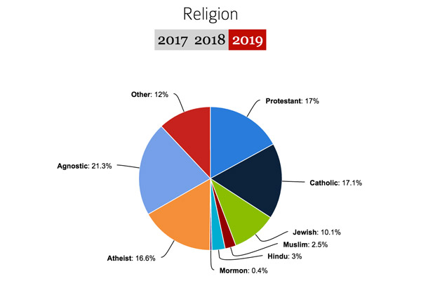

https://www.worldreligionnews.com/religion-news/christianity/atheism-on-the-rise-this-year-at-harvard

World Building study, 2019

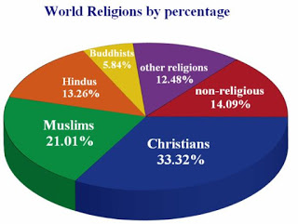

https://writerscheatsheets.blogspot.com/2019/05/2019-may-world-building-religion-and.html

The Globalist:
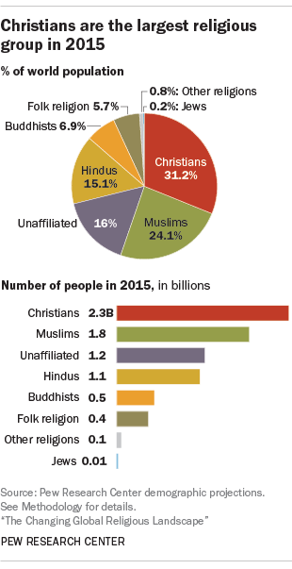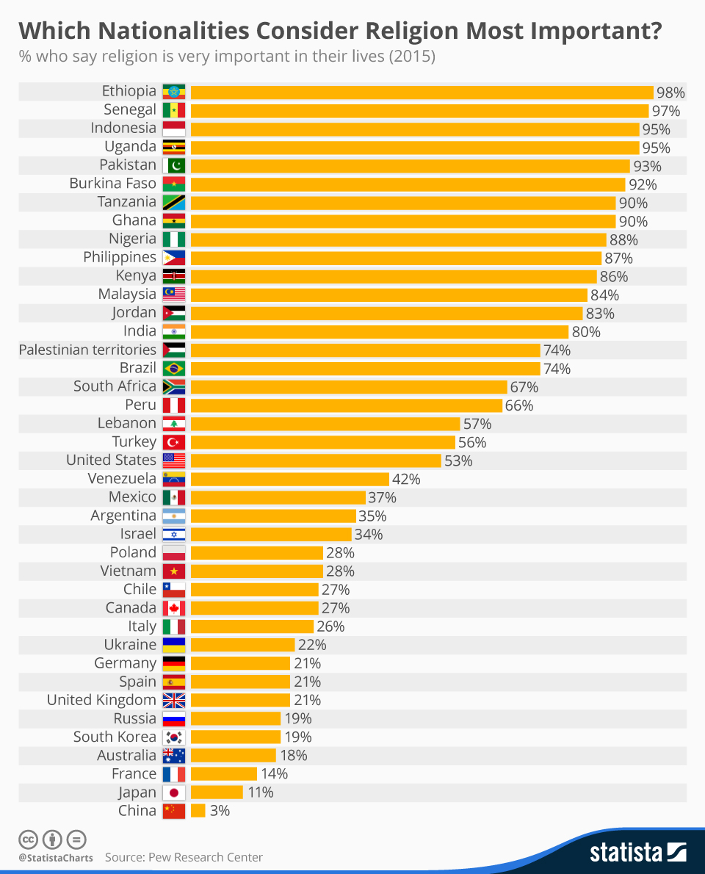

https://www.theglobalist.com/religion-christianity-islam-hinduism-buddhism-judaism/

Bible Characters who were educated in secular philosophy, science, and religion (as well as educated in the Old Testament): Paul, Moses, Daniel, Shadrach, Meschach, Abedneggo

THE HOLY BIBLE

“For the word of God is alive and active. Sharper than any double-edged sword, it penetrates even to dividing soul and spirit, joints and marrow; it judges the thoughts and attitudes of the heart.”—Hebrews 4:12

“Do your best to present yourself to God as one approved, a worker who does not need to be ashamed and who correctly handles the word of truth.”—2 Timothy 2:15

OPENING QUESTIONS:
- How do we know the Bible is God’s Word and that it is accurate?
- Can creation and science both be true, or must you choose one or the other?
- How do we know Jesus lived, died, and rose again?
- Is there any real difference between the Bible and the other major world religions?
- What makes Christianity different from other world religions?
- If the God of the Bible is loving, why is there violence in the Bible, and why do bad things happen to people?
- Your question:

***THE STARTING POINT FOR DISCUSSION:
Even if you don’t believe the Bible or know if you believe the Bible, you probably have an understanding of the Bible’s importance to Christianity and the Western thought. It embodies our religious idea of God the Father, Son, and Holy Spirit as God’s sacred text (rule book, explanation of theology, guide for life). Therefore, we will compare each other ancient sacred text to Christianity/Bible.

HOW THE BIBLE IS SET UP
- 66 books, 40+ authors, over 1600 years, educated & uneducated—kings, peasants, tax collectors, doctors, poets, warriors, prophets, captives, prisoners, murderers, philosophers, immigrants, etc.--men & perhaps women
- One unified message: God’s love & redemption for relationship
- Once central figure/Redeemer: Jesus
- Once central theme: God’s love (proved through creation, relationship, redemption, forgiveness, and empowerment)
- B.C. & A. D.—human history is marked by the life of Jesus from 0 A.D. to 33 A.D.

- Old Testament: (looks ahead to Jesus)
  - Law
  - History (of Israel)
  - Poetry
  - Prophets (of Israel during exile)
- New Testament: (begins with Jesus)
  - Gospels (life of Jesus)
  - History (beginning of the Christian Church)
  - Letters (to churches, about how the church/Christians should function)
  - Prophecy (about the end of human history—Jesus’ eternal triumph)

Check out:
https://www.bibleinfo.com/en/questions/who-wrote-the-bible?fbclid=IwAR1I-zZk0-Oh4I1ZOoSzr0PtjhNMpuuerzOwoRQbCQL4g1pgX6YZzhrf2To#who-wrote-the-bible-infographic

THE RULES OF THE BIBLE
- The 10 Commandments (Exodus 20)
- The Golden Rule (Luke 6:31)
- The Two Greatest Commandments (Matthew 22:36-40)

THE THEME OF THE WHOLE BIBLE

“For God so loved the world that he gave his one and only Son, that whoever believes in him shall not perish but have eternal life. For God did not send his Son into the world to condemn the world, but to save the world through him. Whoever believes in him is not condemned, but whoever does not believe stands condemned already because he has not believed in the name of God’s one and only Son.”—John 3:16-18

Themes in the Bible:
Birth—
Cross—
Faith—
Fire—
Forgiveness—
Grace—
Lamb—
Religion—
Sacrifice—
Slavery—
Special numbers: 3, 7, 12
Sword—
Tree/vine/branches—
Water—

The uniqueness of the Bible and Christianity:
- The Bible uses stories of sinful people (various races, genders, ages, social status, etc.) to teach love, grace, redemption, punishment, relationship, and integrity. It’s the only inclusive religious text in history. Everyone has equal opportunity.
- The Bible is a faith of second chances. While there is punishment and violence against people, God only sanctions it after repeated and blatant rejection of his love. He also uses punishment and suffering as a motivator to bring people back into relationship with him.
- The Bible is the only religious text in which the central figure of God loves everyone equally, regardless of whether they love him back. It is a faith of grace, not merit.
- The Bible is the only religious text in which stories, science, and history align with actual events.
- The Bible is the only religious text in which a deity sacrifices his own life for the someone else, especially not sinful people who might reject him anyway.
- The Bible contains and highlights the only time in human history that someone predicts his own death and resurrection. Over 500 witnesses saw Jesus after his death.
- The Bible contains over 600 prophesies about Jesus’ birth, life, and death, all of which have come true.
- Storytelling is essential to the Bible. It comes in the form of histories, letters, genealogies, parables, eye witness accounts, prophecies, songs, and prayers.

HOW TO FIND THINGS IN THE BIBLE
- To look up a key word, phrase, or reference in the Bible (like an online concordance):
https://www.biblegateway.com
- To look up words in the original language—Greek, Aramaic, or Hebrew (like an online dictionary):
https://www.blueletterbible.org
- To look up maps, lists of miracles, names of God, parables, etc.:
Look in the back of your Bible or on Bible Gateway
*Be careful not to believe what you read on the internet; a lot of people commentate on what the Bible says and means; most of them aren’t educated and speak from a biased, narrow perspective. Learn to do the work and find out.
- To look up information about a particular book of the Bible, look at the beginning of each book; in a study Bible, there will be an introduction written by an editor/theologian telling you about the author, the time period, the history, the contents, message, & theme of the book

SOME BIBLE VOCABULARY:
Atonement—
Canon—
Contextualization—
Eye witnesses—
Incarnation—
Inspiration—
Interpretation—
Prophecy—
Propitiation—
Reconcile—
Redemption—
Resurrection—
Revelation—
Righteousness—
Salvation—
Sin—
Theocracy—
Theologian—
Theology—

WHY ARE THERE SO MANY VERSIONS OF THE BIBLE?
- Interpretation—
- Paraphrase—
- Theology—

“All Scripture is God-breathed and is useful for teaching, rebuking, correcting and training in righteousness, so that the servant of God may be thoroughly equipped for every good work.”—2 Timothy 3:16-17

“Do not add to what I command you and do not subtract from it but keep the commands of the Lord your God that I give you.”--Deuteronomy 4:2

“This is the disciple who testifies to these things and who wrote them down. We know that his testimony is true. Jesus did many other things as well. If every one of them were written down, I suppose that even the whole world would not have room for the books that would be written.”—John 21:24-25

UNDERSTANDING THE BIBLE

“In reference to the Bible, revelation relates to its content or material, inspiration to the method of recording that material, and illumination to the meaning of the record.”—Dr. Charles Ryrie

(Ryrie, Dr. Charles C. “Understanding the Bible,” The Ryrie Study Bible, NIV, Moody, 1986, p. 1781. A Survey of Bible Doctrine. Moody, 1972.)

- Illumination: understanding which occurs through the work of the Holy Spirit
(Jn. 16:12-15, 1 Cor. 2:9-3:2, Jms. 1:22-25, Jn. 8:46-48,)
- Interpretation: understanding which occurs through study of Scripture and community with believers
(Rom. 12, 2 Tim. 3:10-4:5)
- Literal interpretation: examine language plainly. Consider figures of speech, cultural context, consistency with all of Scripture, context in the chapter/book, progress of revelation, law v. grace, poetic language, intended or implied message
- 100 verses that explain why God cannot contradict himself:
https://www.openbible.info/topics/god_cannot_contradict_himself

“For God is not a God of confusion but of peace.”—1 Cor. 14:33

“It is impossible for God to lie.”—Heb. 6:18

To understand any religious text, you must ask yourself:
- What is the verse actually saying? Is there an absolute and authoritative truth or command here that I should follow? What will happen if I disobey or ignore this?
- What is the context of this verse (history, people, theme, topic) within its chapter and chapter section?
- Who is saying this and what kind of person is he/she?
- How do the ideas and philosophies here support other themes and commands in the Bible?
- How am I supposed to obey and incorporate this truth into my life?

SYMBOL OF CHRISTIANITY: The Jesus Fish

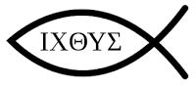
“The ichthys or ichthus (/ˈɪkθəs/^{[1]}), from the Greek ikhthýs (ἰχθύς 1st cent. AD Koine Greek [ikʰˈtʰys], "fish") is a symbol consisting of two intersecting arcs, the ends of the right side extending beyond the meeting point so as to resemble the profile of a fish. The symbol was adopted by early Christians as a secret symbol. It is now known colloquially as the "sign of the fish" or the ‘Jesus fish.’
ΙΧΘΥΣ (ichthys), or also ΙΧΘΥϹ with a lunate sigma, is an acronym or acrostic^{[7]} for Iēsous Christos, Theou Yios, Sōtēr; contemporary Koine , which translates into English as 'Jesus Christ, Son of God, [Our] Savior.’”
https://en.wikipedia.org/wiki/Ichthys

Suggested Reading:
Mere Christianity by C. S. Lewis
The Question of God: C.S. Lewis and Sigmund Freud Debate God, Love, Sex, and the Meaning of Life by Armand Nicholi
The Case for Christ by Lee Strobel
The Case for Faith by Lee Strobel

Conclusions

Some main differences to the Bible/Christianity:
- Jesus is not the Son of God
- God’s mercy is for Muslim believers, not infidels (rejecting Islam)
- Men are more important than women in God’s eyes
- God chooses those He wants and loves those who turn to Him
- God is an enemy to His enemies

The Bhagavad gita

The Bhagavad Gita is the main sacred text for the Hindu religion.
- title means “song of God”
- a collection of 18 books called “discourses”
- guide for how to be happy
- one of many Hindu religious texts
- a conversation between Arjuna a warrior who does not want to kill, and Krishna, “The Blessed One,” who instructs him in the Way

WHAT IS HINDUISM?
- one of India’s 3 main religions (Hinduism, Buddhism, & Islam)
- the world’s 3rd largest religion, with 900 million followers
- a family of religions
- most diverse religion; complex theology and practice
- began at the Indus River
- pantheistic (everything is god) and polytheistic (many gods)
- a religion based on reincarnation, the caste system, polytheism and pantheism
- a works-based system to achieve perfection (one with Brahman state)
- a religion without demonstrations of love, mercy, grace, or forgiveness

Goal of Hinduism: keep being reincarnated into better and better forms until you escape from the samsara process (reincarnation) and reach the Ultimate reality state (divinity/perfection)

The caste system: determines where you live and work; you move up or down in your next life based on what you do now.
- Brahmins--priests
- Kshatriyas—kings, rulers, warriors
- Vaisyas—merchants, craftsmen, skilled workers
- Sudra—farm workers, unskilled workers, servants
- Untouchables/Dalits (below caste)—clean up dirty parts of society; less than animals
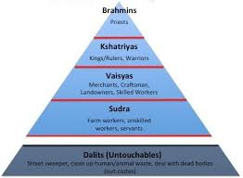

Dalits:
- Poverty, illness, outcasts—being judged for their past lives
- No one will help them; if they are broken out of poverty, they will have to repeat the next life as a Dalit
- They must work their way out of Dalit status through Karma

- Justice in Hinduism=NOT helping people
- Often accept Christianity—they receive the gospel eagerly; they have never heard of love and grace; or being created in the image of God.

Major characters and terms:
- Krishna--chariot driver in The Bhagavad Gita; he argues with Arjuna to do his sacred duty, arguing for war and separation from self; the Hindu god-in-the-flesh
- Arjuna—a warrior in the chariot, getting wisdom/theology from Krishna
- Samsara=the cycle of birth, death, rebirth; process of reincarnation
- Karma=the principle of justice (“what goes around comes around”) that determines reincarnation and journey through Samsara
- Shiva, Vishnu, Brahma--3 main gods
  - Shiva: a destroyer of wicked
  - Vishnu: Protector of his devotees- also has many avatars
  - Brahma : Creator
- Komasutra—erotic text
- Yoga=“duty”; caused by action
- Avatars=gods in the form of a person or animal in the material world

How to advance through Samsara=THE 3 YOGAS (3 ways)
*Karma decides
1. way of actions—do the action but separate yourself from it (3:19)
2. way of knowledge—become one with Brahman - not separate from universe (13:30)
3. devotion to god—worship, “Bhakti” (18:65, 13:11-18, 14:26)

KRISHNA’s characteristics:
- Faultless
- Gives joy
- Full of knowledge
- Makes “I am” statements
- Is worshipped
- Is the way to eternal life
- Manifests himself in human form
- Many ways to reach Krishna
- He decides your eternity
- Does not sacrifice himself for people or love people

The compassionate buddha

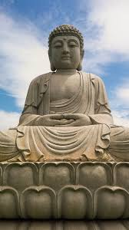
The Compassionate Buddha is a collection of the writings of Buddha.

WHO WAS BUDDHA?
- Lived from 566-486 B.C.
- Named Prince Siddhartha Gautama
- Was called the “sage of Shakya clan”
- Born in the area of modern-day Nepal
- On a spiritual quest to overcome suffering
- Tried living in luxury without being exposed to sickness and suffering
- Became “enlightened” under the Bodhi tree; Buddha means “enlightened one”

What is Buddhism?
- Came out of Hinduism
- Dharma=doctrine, philosophy of Buddha
- Goal is enlightenment & perfection=Nirvana
- Values 4 Noble Truths:
  - all life is suffering
  - suffering comes from desire
  - suffering ends when you stop desiring anything
  - the way to end suffering is the Nobel 8-fold Path:
    - right understanding (worldview)
    - right thoughts
    - right speech
    - right action
    - right livelihood
    - right effort
    - right mindfulness
    - right meditation
- 8-fold Path leads to Nirvana
  - Nirvana is the way to escape Samsara (cycle of reincarnation)
  - Nirvana=“blowing in and out”
  - Completely losing yourself=eternal bliss

DISCUSSION QUESTIONS FOR HINDUISM & BUDDHISM

Directions: Read the samples provided and consider the following questions. You will want to cite the references in the text (use ch. #s and page #s) so you can find them later.

The Bhagavad Gita

- Hindus believe that a person becomes sacred (supreme wisdom and deity) by separating themselves from the earth. What do you think about this?
- Arunja explains his struggle with killing people in The First Discourse, ch. #40-47. (He also explains the philosophy behind the caste system.) Krishna responds to his grief in The Second Discourse. Look at ch. #1-3, 10-13,16-27, 31, 37-38. Discuss both viewpoints.
- Read Second Discourse ch. #47- 53, 55-56, 62-66 and Third Discourse ch. #19. Discuss yoga (discipline) and the process of self-actualization. What do you think of this philosophy? How has this philosophy infiltrated modern America?

The Compassionate Buddha

- Do you think Buddhism is more pessimistic or optimistic and explain why?
- Do you think Buddha is compassionate? Why or why not?
- In what way are the 4 Noble Truths similar and dissimilar to Christian teaching? Explain.
- Read the top of p. 26. Discuss how you can “be a lamp unto yourself.” Compare this thought to Psalm 119:105.
- Read pages 30-31. What do you think about this path to Nirvana?

THE Qur’an

“The entire religious life of the Muslim world is built around the text of the Qur’an.”

History of the Qur’an & Muhammad

- 570 –Muhammad is born
- Muhammad is Allah’s Prophet; (Prophet is always capitalized)
- Mecca—the Islam’s central place of worship; where Muhammed received his revelation; a pilgrimage to Mecca is an important part of Muslim faith
- Medina—the second holy city, an historical haven for Muslims
- 610—first revelation of the Qur’an; revelation from Allah through Gabriel to Muhammad
- Took 23 years to collect; scribes wrote down verbatim what Muhammad said
- Each section is called at sura; each begins with “In the Name of God, the Lord of Mercy, the Giver of Mercy”
- Pieces were placed in 114 sections according to how they were to be read by Prophet and believers
- 632 C.E.—all the pieces of the Qur’an are written down by 29 scribes; most pieces have been learned by heart by scribes and close followers
- Qur’an contains 6200 verses—most “deal with general principles of justice, kindness, and charity” (xviii)
- Earliest versions depended on and referred to the OT leaders (Noah, Abraham, Jacob, Joseph, Moses, Jesus) and stated that they “preached the same message and that the Qur’an was sent to confirm the earlier messages.” (xviii)
- Muslim children begin learning parts of the Qur’an by heart in school; The Qur’an is read on radio and TV in Muslim countries
- A hafiz is a person who learns the entire Qur’an by heart, a prerequisite for many Muslim schools
- The Qur’an contains stories that add to the narratives of Jesus, Mary, Abraham, Noah, Joseph, Abraham, etc.

Main themes of the Qur’an
Unity of God, evidenced by his “signs” (ayat)
Prophethood of Muhammad
Mercy & obedience
Final judgment

Stylistic features—consistent to Arabic
Shifts between first, second, and third person
Verb tenses
Topics
Generalizations
Dialogue without quotation marks or introduction
Arguments interrupted with narratives

Some of the holy books of Islam (written by other people):
Tawrat (Torah or the Law) revealed to Musa (Moses)
Zabur (Psalms) revealed to Dawud (David)
Injil (the Gospel) revealed to Isa (Jesus)
Qur’an revealed to Muhammad (THE PROPHET)

Watershed issues:
- Allah v. God
- Jesus v. Muhammad
- Love and mercy
- Judgment, justice, and forgiveness

Love & mercy—Psalm 85
Ps. 78:38, Eph. 4:32, Col. 2:13, Ps. 32:5, Lk. 7:42

The Qur’an—every sura (chapter) begins with: “In the Name of God, the Lord of Mercy, the Giver of Mercy”
“The Qur’an is above all a book of guidance, each sura adds to the fuller picture and to the effectiveness of the guidance.” (xix)

DISCUSSION QUESTIONS

- How is Muhammad different from Jesus?
- How is Allah different from the Jewish/Christian God?
- How does Allah view infidels (non-believers)?
- Read the verses given above under “Love and Mercy.” Compare love & mercy as topics in the Qur’an and Bible.

Suggested Reading/Sources:
Nabeel Qureshi. Seeking Allah, Finding Jesus: A Devout Muslim Encounters Christianity. Zondervan, 2018. (New York Times Bestseller)
The Qur’an. M.A.S. Abedel Haleem, trans. Oxford, 2008.

Tao te ching

Tao te ching—the Chinese book of philosophies for living
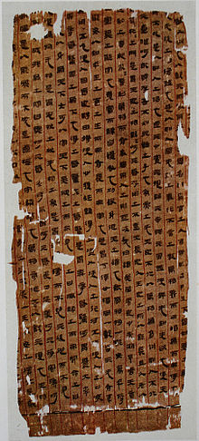
(pronouced Dao De Jing)
Tao= “way”; “implies the essential, unnamable process of the universe”
- Essence, order of the universe
- Goal of ultimate reality
- Precepts for human behavior
Te= “virtue, personal character, integrity”
Ching= “canon, great book, classic”
Tao te ching= “the classic way of virtues” or “the classic book of integrity and the way”

- Versions of the Tao Te Ching date back 2000 years, written on bamboo and silk
- 250 translations
- Most translated book in the world besides the Bible

Lao-Tzu (“Loutsa”)—author of the Tao te ching; lived in 500 B.C. in the Axiel Age, during a time of other ancient philosophers and thinkers:
- Buddha
- Confucius
- Plato
- Socrates
- Jeremiah
- Daniel
- Ezra
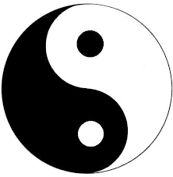
- Mahaviro (Jainism)

WHAT IS TAOISM?—a Chinese philosophical school of thought and religion

- Philosophical—reflective, living in harmony with the tao (the way)
- Pantheism: 3 “Pure Ones” at the top, many deities
- Religious—gods, goddesses, temple
- 5 Phases: wood, water, fire, metal, earth
- steps for achieving ecstasy
- when more man interferes with the natural laws, disharmony occurs
- “go with the flow” mentality
- Yin and yang—dark/light; dualism; opposite forces complement one another
- Goal of longevity and immortality
- Exorcism

General Taoism beliefs: Main 3 are SIMPLICITY, PATIENCE, COMPASSION
- Mystery and manifestation come from darkness
- Beings and non-beings create each other
- Action occurs without doing anything
- Emptying of the mind—look within yourself
- Live humble, simple, fair, generous, present in this world
- Love and lead without imposing will
- Love and accept the world as it is
- Realization of truth brings tolerance
- Throw away holiness, morality, justice, righteousness; let things take their course
- Recognize myself in the Tao/the Way
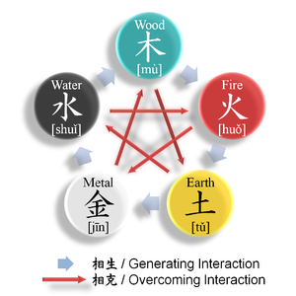
- The universe follows the Tao
- Centering on the Tao brings peace
- Believe in yourself
- True wisdom seems foolish
- Government is repression
- Knowing your enemy is bad

“I am the Way, the Truth, and the Light. No one comes to the Father except by Me.” --John 14:6

DISCUSSION QUESTIONS:

Read the excerpts from the Tao Te Ching and consider these questions.

- Read John 14:1-21. How is Jesus’ teaching different from Taoism? Compare perspectives about Jesus or the Tao providing comfort and hope.
- Read Job 5:7. Compare this philosophy to Taoism. What is appealing about Taoism?
- Read Ecclesiastes 3. How are Solomon’s philosophical struggles similar and dissimilar to Taoism?
- Read Ecclesiastes 12: 9-14, where Solomon sums up his philosophy of life. How is this similar or dissimilar to Taoism?

How is Taoism similar to the New Age Movement today? What do you know about the New Age that reminds you of Taoism?

The Analects of confucius

Compilation of the Analects of Confucius:
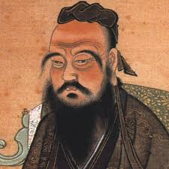
- analect=a principle or wise saying
- The Analects are a collection of Confucius’ early writings
- Confucius (called “Master Kong”) lived approx.. from 551-479 B.C. in China
- 500 short pieces, organized into 20 books
- The books considered truly authentic to Kong are 3-9 and 11-15

Values perpetrated by Confucius:
- Golden Rule, Silver Rule, and reciprocity
- self-control, moderation
- Learning and duty
- Self-focused
- Family sacrifice; family hierarchy (women subordinate)
- Action
- Loyalty
- No faith, love, or grace

DISCUSSION QUESTIONS:
- Compare/contrast Tao Te Ching and Confucianism. What do you notice about Chinese philosophy and culture?
- Read Proverbs 6:16-24. How is this passage similar in style and philosophy to Confucius (p. 66-67)? How are the conclusions different?

